GreenHouse Auto Monitor

User guide of automated plant growth monitoring system

Xiaomin Wu 110151559

GREENHOUSE+  long island 11733, NY

**Table of contents**

**Introduction …………………………………………………………………………………….2**

Overview …………………………………………………………………………………2

Components…………………………………………………………………………….2

Features ………………………………………………………………………………….2

**Front panel ……………………………………………………………………………………..3**

**LCD display ……………………………………………………………………………………..4**

Display mode 1 ……………………………………………………………………….4

Display mode 2 ……………………………………………………………………….4

Display mode 3 ……………………………………………………………………….5

**4X4 keypad layout …………………………………………………………………………..6**

**Rear panel design ……………………………………………………………………………8**

**Operation mode ……………………………………………………………………………..9**

Temperature and humidity measuring and display mode .……...9

Current time and alarm time setting mode ……………………………..9

CO2 density measuring and display mode ……………………………….9

**Getting start guide ………………………………………………………………………….10**

Power on ……………………………………………………………………………….10

Set current time and alarm time …………………………………………….10

Read CO2 density …………………………………………………………………..10

**Introduction**

**Overview:**

Temperature, CO2 density and humidity are important environment parameters for plant growth. Automated plant growth monitoring device is an embedded system application to monitoring the temperature, CO2 density and humidity for better control plants’ growth.

**Components:**

The system is built on ATmaga128 microcontroller with humidity and temperature sensor, CO2 sensor, real time clock chip and 4X4 keypad.

1. ATmaga128 microcontroller
2. Honeywell HumidIcon™ Digital Humidity/Temperature Sensors
3. DS1306 Serial Alarm Real-Time Clock
4. SEN0219 Analog infrared CO2 Sensor
5. Liquid Crystal Displays (LCDs)
6. 4X4 keypad

**Features:**

1. Long operating period per battery change.

The software runs on the system is designed to make the entire system energy efficient, so that the monitoring device can be used for long time without changing battery. T

1. User interact allowed.

he device also displays time and can be set by the user. Alarm can also be set for certain control at specific time, for instance, temperature should be increased during the night and decrease at morning.

This user guide will inform you about the basic components of the device, all operation modes of the device, how to power on and use the device. After reading this guide, user can easily use the device with all functions.

**Front panel design:**

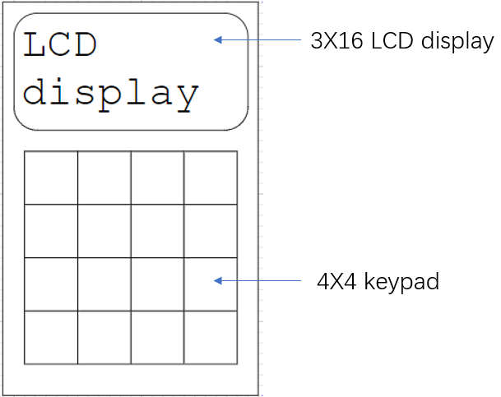

Figure 1 front panel design

Our device is designed to have a 3X16 LCD display to show the monitoring result including temperature, humidity and CO2 density with a current time display. A 4X4 keypad is put on the front panel to set and control the device, like set the current time and alarm time.

**LCD display:**

**Display mode 1:**

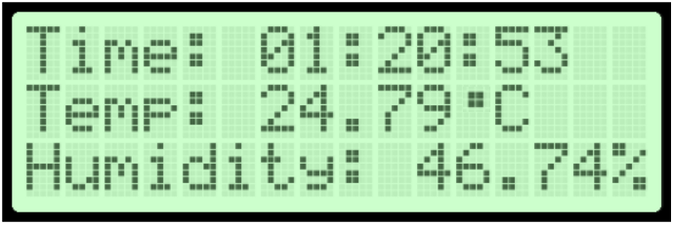

Figure 2 LCD pattern under display mode 1

The LCD displays current time, temperature and humidity result. This mode is used idle FSM state.

**Display mode 2:**

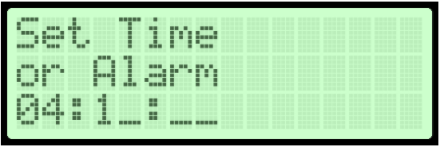

Figure 3 LCD pattern under display mode 2

The LCD displays the hour, minute and second input one by one by the user. It also displays a title set time or alarm on the top to indicate that the device is in a setting stage for current time or alarm time. To set current time, set time key on keypad should be pressed after input wanted value. To set alarm time, set alarm key on keypad should be pressed after input finished.

**Display mode 3:**

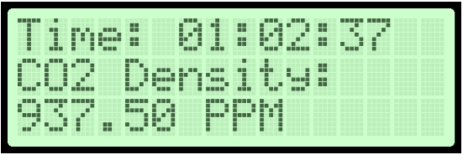

Figure 4 LCD pattern under display mode 3 with valid sensing result

LCD displays the current time and the CO2 density result. This mode is used when user pressed keypad for checking CO2 density. The device will be in a CO2_check FSM state. The CO2 display only valid after the analog output voltage of CO2 sensor (SEN0219) gets higher than 0.4V.

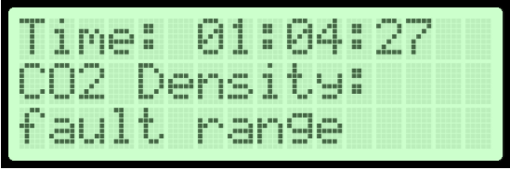

Figure 5 LCD pattern under display mode 3 with fault range

LCD displays the CO2 result as ‘fault range’ when the output voltage of the CO2 sensor(SEN0219) is between 0V and 0.2V.

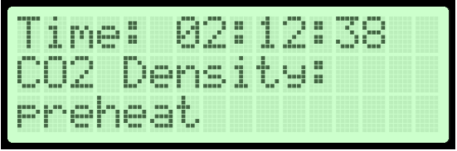

Figure 6 LCD pattern under display mode 3 with preheat condition

LCD displays the CO2 result as ‘preheat’ when the output voltage of the CO2 sensor(SEN0219) is between 0.2V and 0.4V

**4X4 keypad layout:**

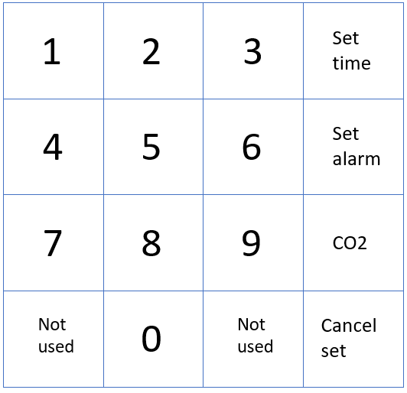

Figure 7 4X4 keypad layout

**Key function:**

•0-9 number key: make device run into time setting mode, and input number digits under time setting

mode.

•Set time key: set the input decimal digits into current time and make the device return to temperature

humidity measuring mode from time setting mode.

•Set alarm key: set the input decimal digits into alarm time and make the device return to temperature

humidity measuring mode from time setting mode.

•CO2 key: make the device run to CO2 measuring and display mode from the temperature and humidity

measuring and display mode.

•Cancel set key: abandon the un finished time setting and return to temperature humidity measuring

and display mode from time setting mode.

**Rear panel design:**

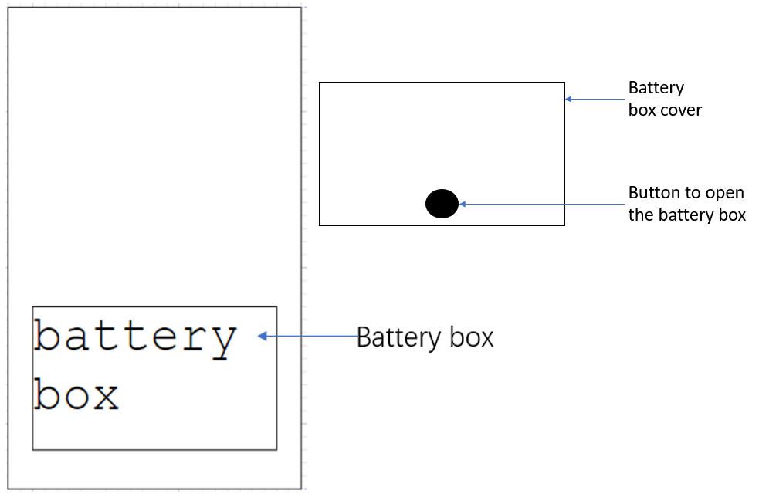

Figure 8 device rear panel design

A space for two AAA batteries is on the rear panel of the device. The device does not need an on/off switch to control. The device will run immediately after the battery was put in. Press the button on the battery box cover to open the battery box.

**Operation mode:**

**Temperature and humidity measuring and display mode:**

Device measures humidity and temperature and display the measurement result on LCD display under this mode. This mode is the default operating mode, which will run after power on the device.

**Current time and alarm time setting mode:**

Device runs into the current time and alarm time setting mode after user press any number key on the keypad when the device is on either temperature and humidity measuring and display mode or CO2 density measuring and display mode. Under this mode, the LCD display of the device will echo the user inputs. User can input six decimal numbers into the device, they will be used as hour, minute and second in sequence. After user input those values, two confirm keys are expected to be pressed by the user. if the user wants to set the input value to current time, then the ‘set time’ key on the keypad should be pressed. If the user wants to set the input value to alarm time, then the ‘set alarm’ key on the keypad should be pressed. After confirming key pressed, device will run back to temperature and humidity measuring and display mode.

**CO2 density measuring and display mode:**

Device runs into the CO2 density measuring and display mode after user press the ‘CO2’ key on the keypad. The device under this mode will get the analog output signal from the CO2 sensor and do an analog to digital conversion then display the digital measurement result on the LCD display.

**Getting start guide:**

1. **Power on: (In short, put battery in the device)**

Open the device’s battery box cover at the rear panel by pressing the battery box button. Put two AAA battery into the device’s battery box with correct anode and cathode direction. And close the battery box’s cover by simply pressing it in. You will see the LCD display of the device is displaying temperature and humidity with a 00:00:00 time.

1. **Set current time and alarm time: (In short, press any number key)**

You need to set the time to the current time at your first power on the device. To set the time by press the ‘set time’ key on the 4X4 keypad to let the device run into current time and alarm time setting mode. then you will see the LCD displays ‘set time or alarm _ _:_ _:_ _’ . Six blanks indicate to six decimal value that you can input in, begin with the first blank when you press any number key on the 4X4 keypad. Those six decimals are corresponding to the hour, minute and second to set current time or alarm time. ‘set time’ key should be pressed after you complete the input and want to set those decimal value to current time. Or you can press the ‘set alarm’ key to set the decimal value to alarm time. When the current time hit the alarm time, the device will give alarm. If you set wrong number by wrong clicking on the keypad, you can keep input other values in, and the cursor will go back to the wrong position. The six decimal position are looping when you only press number keys without press confirm key. In this way, you can easily change the wrong time you input.

1. **Read CO2 density: (In short, press the CO2 key on the keypad)**

After setting current time, the device should read temperature and humidity correctly with a current time display on the LCD. To read and display the CO2 density, you need to press the ‘CO2’ key on the keypad. After the key pressed, the device will display current time and the CO2 density on the LCD. You can control the device to return to the temperature and humidity measuring and display mode by press the ‘CO2’ key again when device is under CO2 measuring and display mode. you can also set the current time and alarm time by pressing any number key on the keypad.